DATA ANALYTICS WITH TABLEAU

Assignment-2

Name:- Patrurla Prasanth

Mail Id:- prasanthpatrurla@gmail.com

Roll No:- 20PC1A0516

College:- Vizag Institute of Technology

**DONUT CHART**

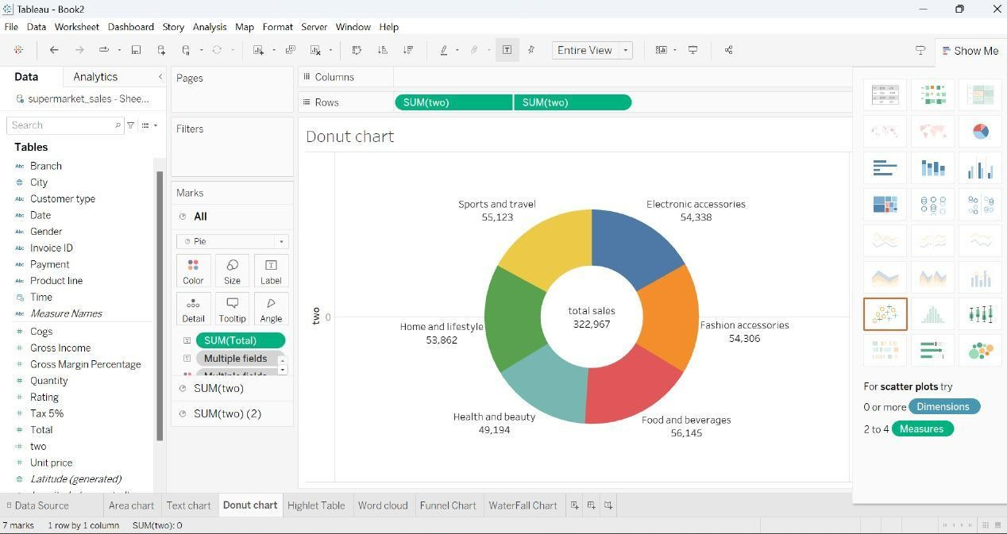

**AREA CHART**

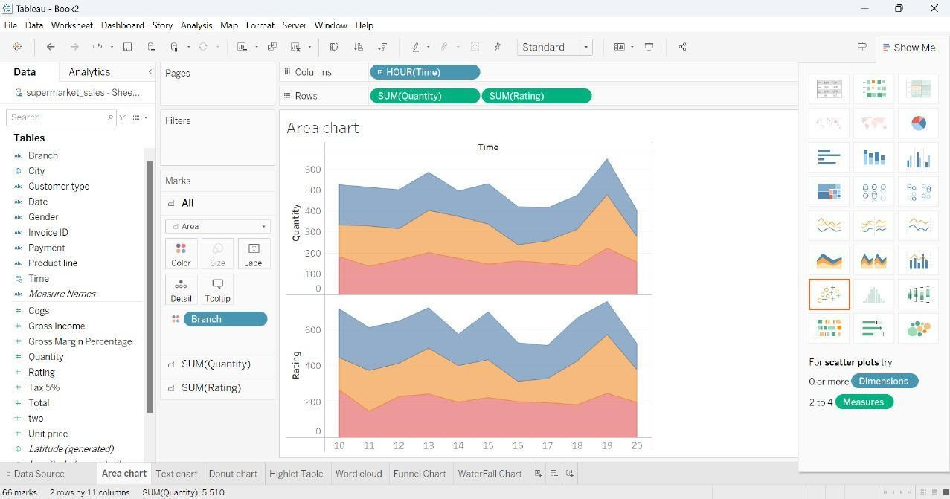

**TEXT TABLE**

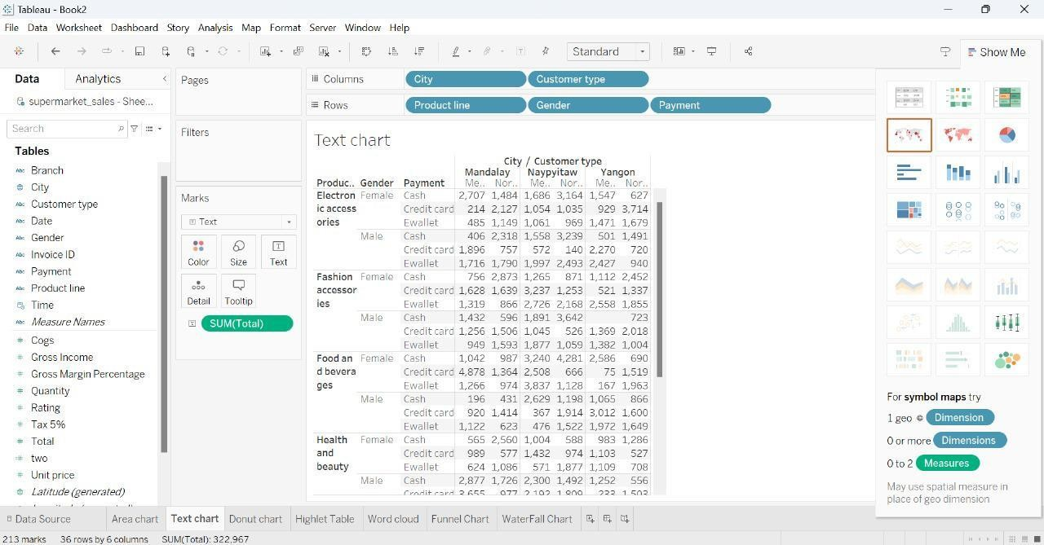

**HIGHLIGHTED TABLE**

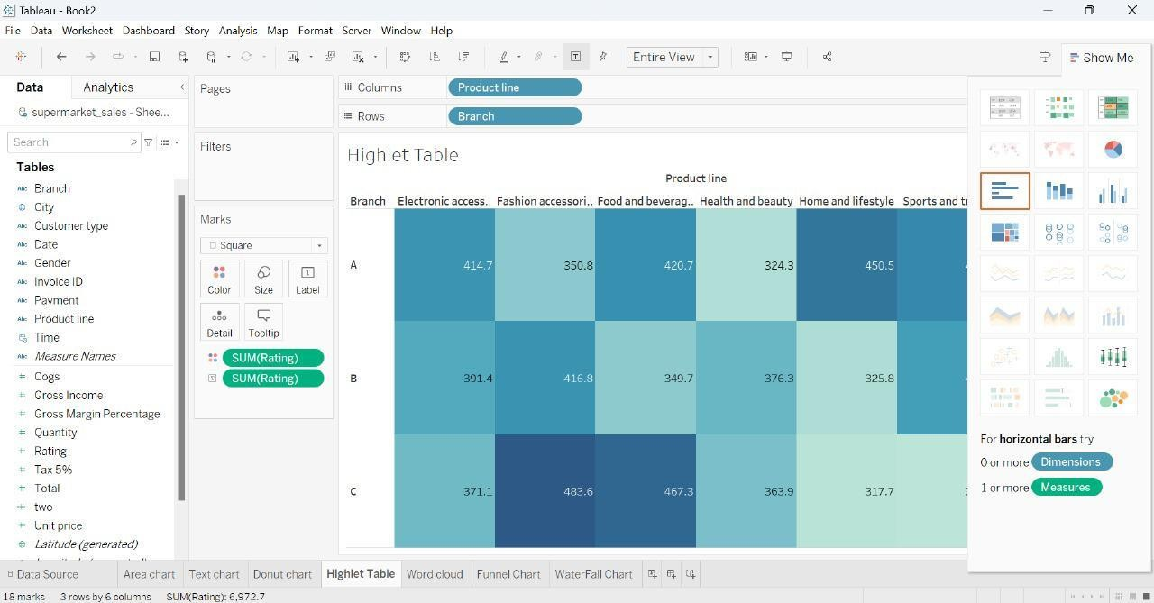

**WORD CLOUD**

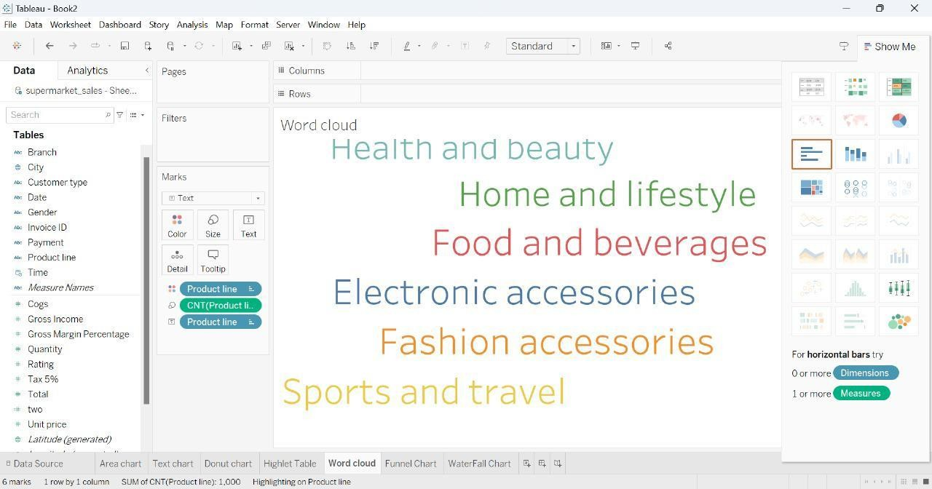

**FUNNEL CHART**

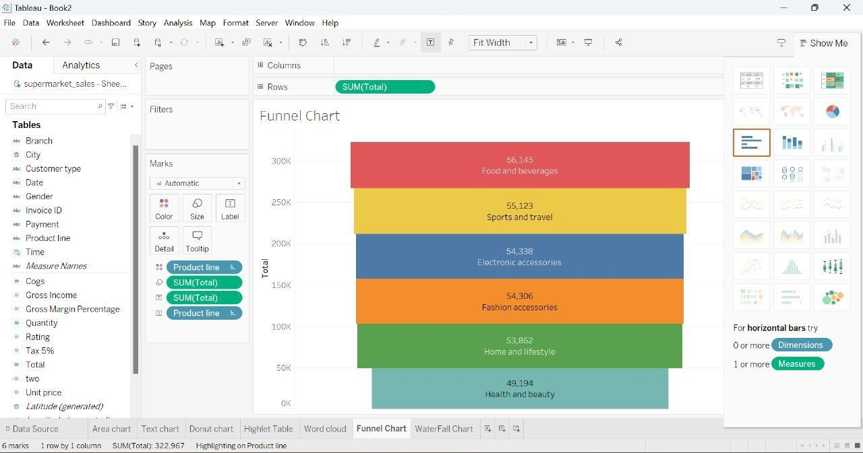

WATERFALL

